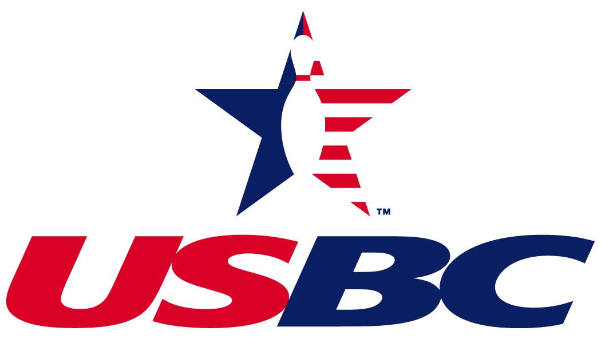
 Polish Bowling Tournament
81st Annual Michigan State

► ►Open to ALL USBC Men and Women Bowlers (Polish and NON-Polish) See Rules for Details►►

Gender specific tournament (Men Only -or- Women Only)
Endorsed by the Michigan State Polish Bowling Association
__________________________________r_______________________________________________________________________
M-66 Bowl
19794 Capital Ave NE Battle Creek, MI. 49017 (269) 962-9597
56 Lanes (Handicap is 80% of 230)

SINGLES & DOUBLES on Saturday’s TEAM on Sunday’s

March 29 – 30 April 5 – 6 April 12 – 13 April 26 – 27 May 3 – 4
2 squads every weekend
(May 3-4 AM is reserved for Joe Jablonski’s squad only)

► ► you Pay with a Check / Credit Card / Venmo / PayPal

Estimated Team 1st Place Payout
Men $ 3,000 (Based on 200 Team Entries)
Women $ 800 (Based on 50 Team Entries)
(The Prize ratio will be at least 1 out of 7 entries in each event)

ALL ENTRIES CLOSE FEBRUARY 28th

Late Fee of $10 will be charged if not postmarked by the Above Date
__________________________________________________________________________________________________

COMPLETE AND RETAIN FOR YOUR RECORDS

Choice of Squads - Day and Time: NO MONEY WILL BE REFUNDED AFTER
REGISTRATION CLOSES.
Team: 1st: _______________ Time: ________
All Fees MUST accompany entry Form
2nd : _______________ Time: ________ Make all Money Order or Checks
Singles & Doubles: Payable to: MSPBA
1st: __________________ Time: ________ Fill out entry Form on Back and
Mail To: John D Masters, MSPBA Headquarters
2nd: __________________ Time: ________ 319 Washington St Otsego, MI. 49078
Phone: (616) 307-4886 WWW.MSPBABOWLERS.COM email: mspbamail@aol.com
The 81st Annual Michigan State Polish Bowling Tournament will be held at M-66 in Battle Creek, MI. Saturday & Sundays starting
March 29th and ending May 4th, 2025. In our 80th Annual Tournament in Muskegon MI. total entries were:
Team Doubles Singles
Men 249 617 1,231
Women 44 117 235
RULES AND REGULATIONS
This tournament is sanctioned by the United Stated Bowling Congress. All bowlers must be USBC sanctioned to participate
(Weekend USBC Sanctions can be purchased at tournament site for $5).
The prize funds will be returned 100% in prize money, plus trophies for champions in 5-member team, doubles, singles and All-Events.
An 80 % handicap from a 230 average will be awarded. Maximum handicap is 80 per game, per bowler. Multiple entries are allowed but a bowler can only cash once in singles, Doubles (unless different partner), Team (unless 3 different bowlers) & All-Events

RULE 13 - Any unmarried grade and high school student under 18 who attempts to purchase an unattached USBC membership card to bowl in this tournament must have a written consent form signed by their parent or legal guardian prior to bowling. For bowlers under 18 who have a USBC membership issued through a league, if a parental consent form was already given to that league it will be sufficient.

RULE 213 - When a free entry is given, an amount equal to the prize fee for that entry will be paid into the tournament prize fund by the Michigan State Polish Bowling Association.

RULE 319a1 – Bowler will use highest USBC Sanctioned Book Average (minimum of 21 games) from the prior season. If no average last season, use highest current sanctioned average of 21 games or more at the time and date of bowling (bowler must supply a current league sheet at check-in time). If Bowler has no USBC average, then they will use their MSPBA tournament average. Any bowler who cannot qualify as above will establish their MSPBA tournament average with the games bowled during current years tournament.
The bowlers MSPBA tournament average (of 27 games or more) will be used when it is 10 pins or higher than the bowlers USBC average. The MSPBA tournament average will be calculated based on the 6 most recent years that a bowler has bowled. The tournament average that the tournament director has will be the one used.

RULE 319a2 – When the previous season’s average is used, and at the time and date of bowling, an entrant has a current average (with at least 21 games) that is 10 pins or higher than the prior season’s average, the current average must be used.
RULE 319a3 - Bowlers are responsible for verifying their own average, whether submitted by the bowler, team captain or others. If the submitted average is lower than required and results in additional handicap, the bowler’s score is disqualified.
RULE 319a4 – Failure to use the proper average or make a correction prior to completion of the first game of a series shall disqualify score if submitted average is lower than actual average or base prize winnings on submitted average if it is higher.
RULE 319c – The average of a bowler may be adjusted upward before participation in any event.

RULE 319d – Bowlers who have qualified for a cash and/or merchandise prize of $300.00 or more in any tournament in the past 12 months must provide tournament management with the name of tournament, amount, position and actual score for possible rerating.

RULE 319e – Tournament Average. If during the 12-month period immediately preceding the time and date of bowling, the bowler’s accumulated average for all, but not less than 21 tournament games, exceeds the average to be used for entry by 10 or more pins, the accumulated average must be used for handicapping. The bowler is responsible for keeping a record of the names, dates, scores, prize winnings and prize position in all tournaments entered in the previous 12 months including those still running. If a bowler has ever been adjusted or rerated during a tournament they must report it to the tournament office at check in or be disqualified.

TO BE ELIGIBLE TO BOWL IN THIS TOURNAMENT, YOU MUST BE EITHER OF POLISH PARENTAGE OR BY MARRIAGE, BE A MEMBER OF A POLISH ORGANIZATION OR PAY PARTICIPATION DUES OF $3.00 PRIOR TO BOWLING IN THE TOURNAMENT.

To speed up the check in process, it is important that each bowlers USBC number be included on this entry blank. All line-ups (team, singles, doubles) entries must appear in the order they will bowl. This is a Gender specific tournament Men & Women cannot be mixed.

If breakdown of pin spotters occurs for 10 minutes, tournament director reserves the right to move bowlers to another pair of lanes. Bowlers being moved will not receive any practice throws on the new pair of lanes.

Members of the PBA and all others deemed professional are eligible to bowl but each team/doubles are limited to One PBA member. Any bowler is considered a PBA until 2 years after membership expires.
Captains will be mailed a copy with schedule dates and times. Prize checks are sent to team captains, so it is important to include their full mailing address and telephone number.

All entrants agree to be bound by the above rules and further agree that all questions arising as to the infractions of said rules shall be submitted to the rules committee. All entrants do hereby agree to be bound by the decisions of the Rules Committee, whose decision in each case shall be final, unless an appeal is made in accordance with USBC Rule 329.

Any bowler who is disqualified for any infraction of our rules forfeits all entry, bowling, and expense fees and all rights to any prize money. This also applies to total team and double entries. Prizes will be paid after averages of all prize winners have been checked and verified. Tournament Committee has full power to accept or reject any or all entries in this tournament. (Respectfully Yours John D Masters)
PLEASE READ CAREFULLY
Optional Senior Handicap Jackpot - $15 per bowler
($15 will get you into all Sr. Handicap events Singles, Doubles and All-Events)

Must be 55 or older AT TIME OF BOWLING
80% from 230

Will pay the Top 10 high Handicap scores in
Singles / Doubles / All-Events (over the whole tournament)
Note: Both Doubles partners must get into Optional Hdcp Doubles
(else the $15 will enter the bowler in Sr. Hdcp Singles/All-Events only)

ALL ENTRIES CLOSE
February 28, 2025

$70 gets a bowler in all 3 events
to include All-Events
ENTRY FEE
Per Person, Each Event: Handicap
Prize Fee $ 8.25 TEAM EVENT:
Expense Fee 13.75 Sunday’s - March 30, April 6, 13, 27 and May 4
Total Per Event: $ 22.00 NO OPEN BOWLING ON TOURNAMENT LANES
All Events $ 4.00
DOUBLES & SINGLES
Prize money to be awarded to at least 1 -7 of the entries Saturday’s - March 29, April 5, 12, 26 and May 3
in each event. Prize money returned 100%
SPONSOR A SQUAD: Squad Sponsor receives 1 FREE individual entry for Each 30 bowlers in ALL events

► ► Note: Each weekend can be combined into 1 squad or separated into 2 squads based on number of entries

First score in team doubles and singles handicap will be NO LIMIT ON MULTIPLE ENTRIES:
Used for All-Events (handicap and Scratch optional) Can bowl multiple times in Each Event
Optional Scratch Jackpots - $20 per bowler ($20 will get you into all Scratch: Singles, Doubles and All-Events)
($15.00 - Prize Fund and $5.00 – Expenses)
Will pay the Top 10 high Scratch scores in Singles / Doubles / All-Events (over the whole tournament)

Note: Both Doubles partners must get into Optional Scratch (else the $20 will enter the bowler in Scratch Singles/All-Events only)

Tournament Committee will assign lanes for all the events
PLEASE SELECT TOURNAMENT DATES CAREFULLY
Re-scheduling will be at the discretion of tournament mgmt in the event of notification from team captains.
► ► ► Up-To-Date Results and Squad listings will be posted on www.MSPBABOWLERS.com
2024 MSPBA TOURNAMENT CHAMPIONS
At Sherman Lanes Muskegon Michigan
Team Men Lattucca #6 3625
Women Llama Drama 3449
Singles Men Marcus Giles 817
Women Leslea Reichard 767
Scratch Marcus Giles 799
Sr. Hdcp Bob Barthel 798
Doubles Men Tim Bailey / Damonde Griggs 1610
Women Kris Clark / Jen Kocks 1505
Scratch Tim Bailey/ Damonde Griggs 1572
Sr. Hdcp Bob Barthel / Joe Borowy 1452
All Events Men John Bercier 2306
Women Yolanda Cocalo 2142
Scratch Jacob Johnson 2277
Sr. Hdcp Bob Barthel 2262

SEND IN YOUR ENTRIES EARLY TO GET YOUR FIRST CHOICE IN DATES AND TIMES.

All Prize checks will be mailed to
TEAM Captains

Tournament Sanctioned by USBC

Entry Fees can be paid by check/ Credit Card/Venmo/PayPal
ENTRY #
- - - - - - - - - - - - - - - - - - - - - - - - - - - - - - - - - - - - - - - - - - - - - - - - - - - - - DETACH THIS PAGE AND SEND IN WITH YOUR PAYMENT - - - - - - - - - - - - - - - - - - - - - - - - - - - - - - - - - - - - - - - - - - - - - - - - - - - - - - - -
Team Name:

Please pair us with

Team or Captains Name

T  E  A  M | First and Last Name | AVG | USBC ID  Please make it easier for Peggy enter ID if known | All-Events  ($4 each)  (Y/N) | Opt. Scratch  ($20 each)  (Y/N) | Opt. Senior HDCP  55 and older ($15 each)  (Y/N) Bowlers AGE
T  E  A  M | 1. |  |  |  |  |  | Only needed if in Sr. Hdcp
T  E  A  M | 2.
T  E  A  M | 3.
T  E  A  M | 4.
T  E  A  M | 5.
T  E  A  M | 6th  Person

Bowlers that enter Doubles must enter Singles, and vice versa.
S  I  N  G  L  E  S  D  O  U  B  L  E  S | Pos. First and Last Name |  | Average | SINGLES  & DOUBLES  $44 Ea. Bowler
S  I  N  G  L  E  S  D  O  U  B  L  E  S | PAIR  1
S  I  N  G  L  E  S  D  O  U  B  L  E  S | PAIR  2
S  I  N  G  L  E  S  D  O  U  B  L  E  S | PAIR  3
Total
Please Fill
in the Amounts

Team $______
($110 per team)

Singles/Doubles
$______
($44 per bowler)

All-Events
$______
($4 per bowler)

Optional Jackpots
$______
Scratch -$20 each
SR. Hdcp-$15 each

$ ___________

Squad Organizers Name: __________________________
Total Amount
Submitted:

$ ___________

CAPTAIN ________________________________________ Telephone ______________________ ►

Address: ___________________________________ City ______________________ Zip __________ ►
CHOICE OF DATES & TIMES (please circle 1st AND 2nd choice for both Team & S/D)
Note: May3 – 4 AM is reserved for Joe Jablonski’s squad only

MAKE PAYABLE TO:
Singles/Doubles (Saturday’s)
1st Choice 2nd Choice
Mar 29 (8:30 or 1:30) Mar 29 (8:30 or 1:30)
Apr 5 (8:30 or 1:30) Apr 5 (8:30 or 1:30)
Apr 12 (8:30 or 1:30) Apr 12 (8:30 or 1:30)
Apr 26 (8:30 or 1:30) Apr 26 (8:30 or 1:30)
May 3 (8:30 or 3:00) May 3 (8:30 or 3:00

Team (Sunday’s)
1st Choice 2nd Choice
Mar 30 (9:00 or 1:00) Mar 30 (9:00 or 1:00)
Apr 6 (9:00 or 1:00) Apr 6 (9:00 or 1:00)
Apr 13 (9:00 or 1:00) Apr 13 (9:00 or 1:00)
Apr 27(9:00 or 1:00) Apr 27 (9:00 or 1:00)
May 4 (9:00 or 1:00) May 4 (9:00 or 1:00)

MSPBA
MAIL TO: John D Masters
Mail to:
MSPBA Headquarters
319 Washington St
Otsego, MI. 49078

Pay Options: Mail check or by Credit Card (5% fee) Enter your phone number: ____________________
and John Masters will call to get the information. (Please do not send credit card information on the entry form)
or by PayPal ( username: PolishBowling) or by Venmo ( username: PolishBowling and phone: 4886

